New business in Quito – Ecuador

# Introduction

## Description & Disscusion of the Background

The city of Quito, located in the province of Pichincha in the Republic of Ecuador and the capital of the same, had approximately 2,644,145 inhabitants in 2017 and is the second most populated city in the country, with Guayaquil being the first, and it is estimated that in 2020 it will be the most populated canton in the whole country with 2,781,641 inhabitants, it will grow by 5.2%, according to the population projections of the INEC (National Institute of Statistical Studies and Censuses)

The Metropolitan District of Quito, is the administrative area number nine, has nine districts, 32 urban parishes and 33 rural parishes according to the official record 290 and was declared a World Heritage Site by UNESCO on September 18, 1978, is therefore , this The city is the preferred destination for tourists in Ecuador, according to the Ministry of Tourism, approximately 66,741 tourists come to stay in their hotels and the figures increase year after year.

Taking into account all these figures, it is a priority that when opening a new Business in this city, we know what is the offer of this service in Quito; In this case, there is an establishment where you want to set up a new business, without which you do not know what type of business should be appropriate to set up, which is why conducting an investigation of the business offer near our establishment is the first step before opening any business

# Data Description

The data that will be used comes from the Foursquare platform, where in the case of Quito there are not enough people who know about this application, so there are not enough contributions from new places or references, so the data provided by the platform, we will be served by a referral for the opening of the new business.

# METHODOLOGY

This study focuses on the main tool of Jupyter Notebooks for geospatial processing and the Foursquare platform for collection, storage and analysis of the places of tourist concurrence within the Metropolitan District of Quito, in order to diagnose where and which places are They are close to the location of our new business location.

In as much, the methodology is based mainly on 2 stages:

1. Descriptive statistical analysis: libraries included in Python will be used, such as the Pandas library for processing tables, the Numpy library, to relay descriptive analysis of data, among others ...
2. Spatial analysis: where the places of interest are represented uploaded to the Foursquare platform at the Historic Center of Quito.

# RESULTS

In the first place you want to know the geographical coordinates of the location of our business, in this case we only have the address that is "Iquique and Concepcion", located in the center of Quito, in the parish "Centro Historico", so the credentials of the Foursquare API will be used to locate it geographically.

In this case, the coordinates of our business are:

COORDINATES:

-0.2236462 -78.5155931

Once the coordinates of our business are established, we want to know what kind of businesses are located around them, so we will ask Foursquare which businesses are within a radius of 500 meters. The businesses that are located around are:

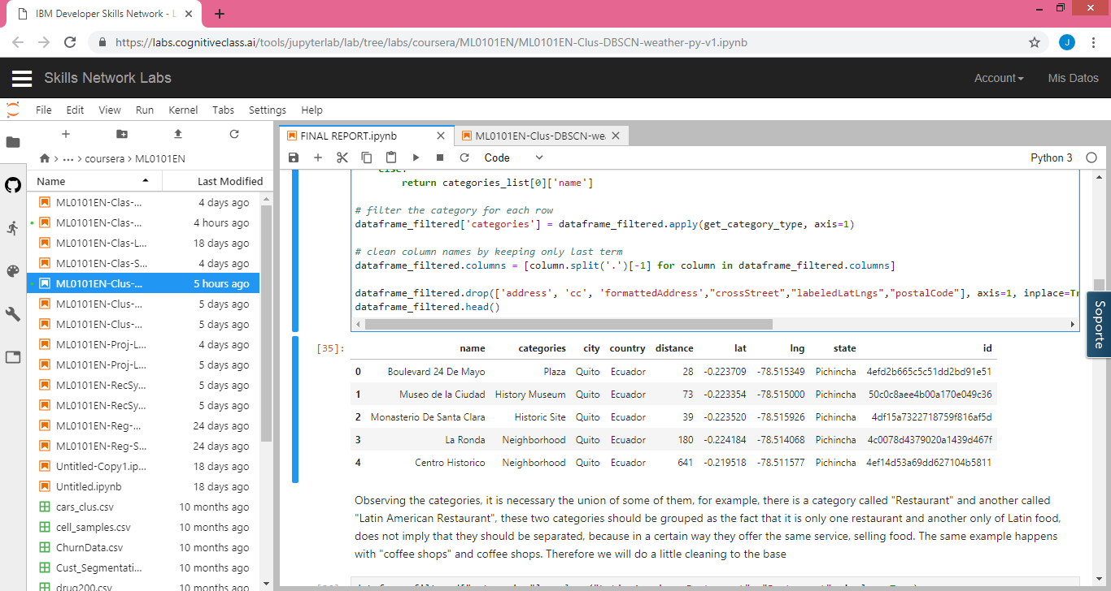

Observing the categories, it is necessary the union of some of them, for example, there is a category called "Restaurant" and another called "Latin American Restaurant", these two categories should be grouped as the fact that it is only one restaurant and another only of Latin food, does not imply that they should be separated, because in a certain way they offer the same service, selling food. The same example happens with "coffee shops" and coffee shops. Therefore we will do a little cleaning to the base

So once the database is cleaned, we can observe the local businesses that are close to our new business location and what better way to do it, using a map like the following:

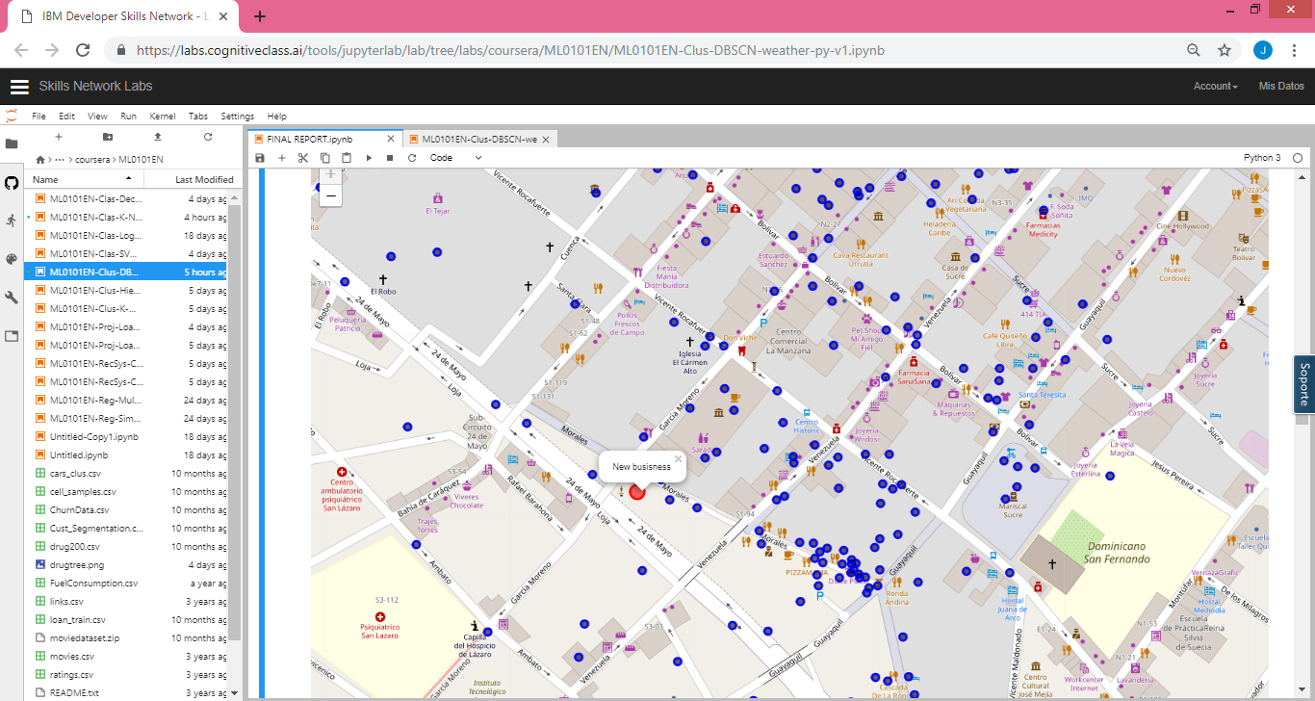

Now, it is necessary to know how many and what kinds of businesses exist around the Historic Center, for which a bar graph was created so that we can visualize which are the most frequent types of businesses. The businesses around are:

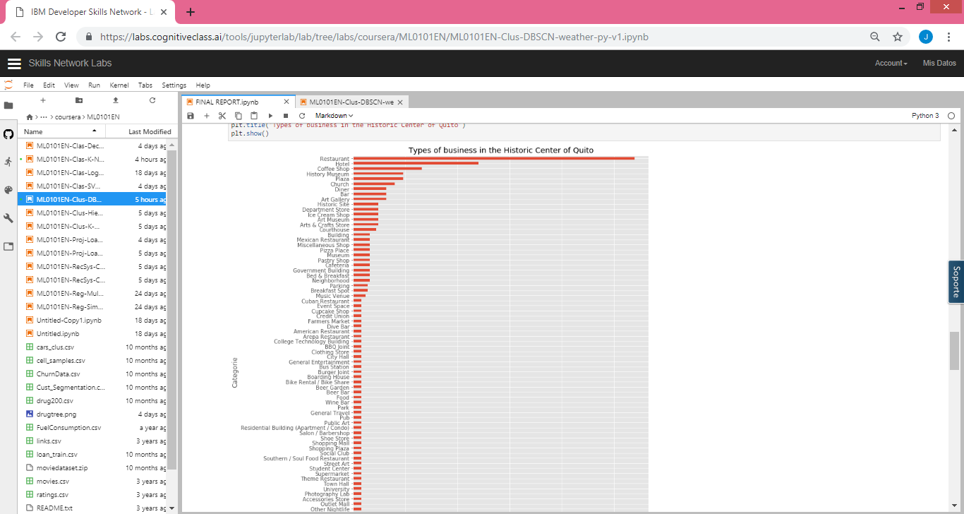

As we can see, there are 91 types of businesses that work in the Quito Center, making it clear how is the market within this area, however, would it be recommendable to open a business that is already quite frequent in this area? , indeed NO, that is why we have selected the 15 most frequent businesses in the area and we have separated them from the rest, in a way that allows us to evaluate what is the most common market in the Quito Center

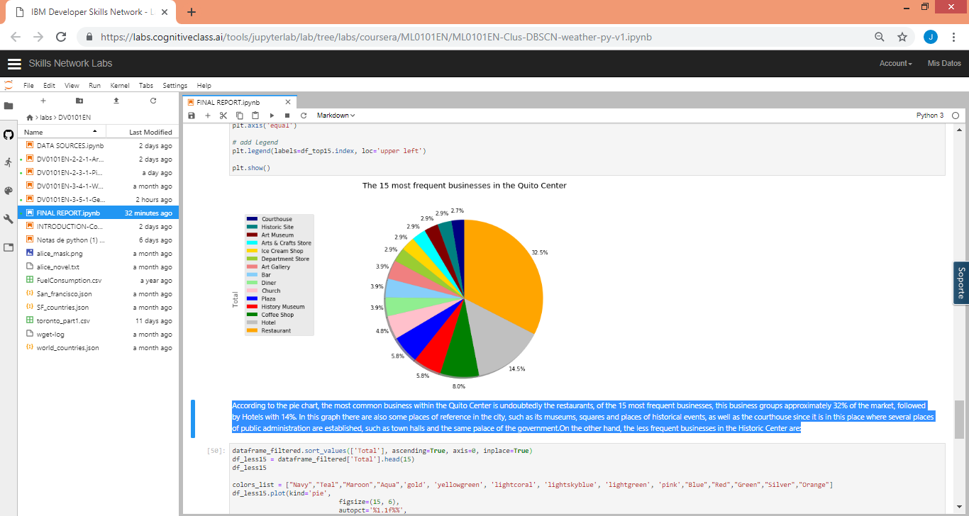

According to the pie chart, the most common business within the Quito Center is undoubtedly the restaurants, of the 15 most frequent businesses, this business groups approximately 32% of the market, followed by Hotels with 14%. In this graph there are also some places of reference in the city, such as its museums, squares and places of historical events, as well as the courthouse since it is in this place where several places of public administration are established, such as town halls and the same palace of the government.On the other hand, the less frequent businesses in the Historic Center are:

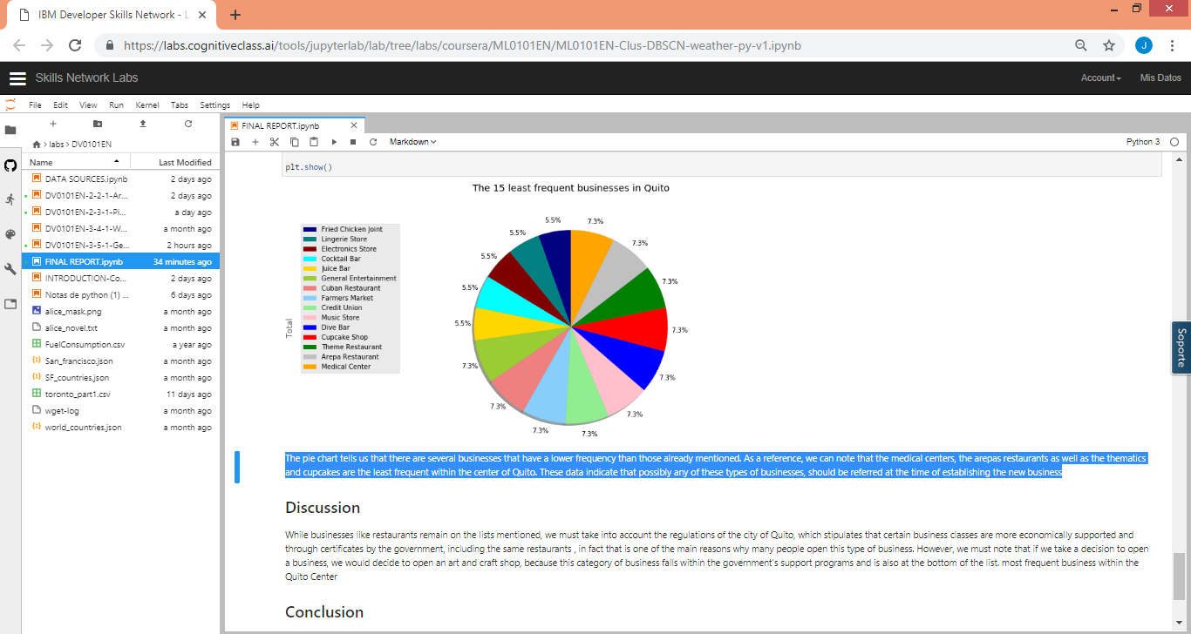

The pie chart tells us that there are several businesses that have a lower frequency than those already mentioned. As a reference, we can note that the medical centers, the arepas restaurants as well as the thematics and cupcakes are the least frequent within the center of Quito. These data indicate that possibly any of these types of businesses, should be referred at the time of establishing the new business

# Discussion

While businesses like restaurants remain on the lists mentioned, we must take into account the regulations of the city of Quito, which stipulates that certain business classes are more economically supported and through certificates by the government, including the same restaurants , in fact that is one of the main reasons why many people open this type of business. However, we must note that if we take a decision to open a business, we would decide to open an art and craft shop, because this category of business falls within the government's support programs and is also at the bottom of the list. most frequent business within the Quito Center

# Conclusion

1. The most frequent business in the center of Quito are the restaurants, in all kinds of food, from Latin American and traditional food, to American or European, even, within the less frequent businesses, the Venezuelan food business is entangled, as the arepas
2. The center of Quito is the epicenter of business and tourist sites, within the most frequented places are squares, churches and historic buildings, including museums.
3. To be able to enter the market in the Center of Quito, it is suggested to establish a business of the type of artisan item sale
4. The location of the business is favorable since it is located in front of a square and is surrounded by coffee shops, so being part of the food business would not be entirely recommended